**UpTrain AI Assignment**

1. 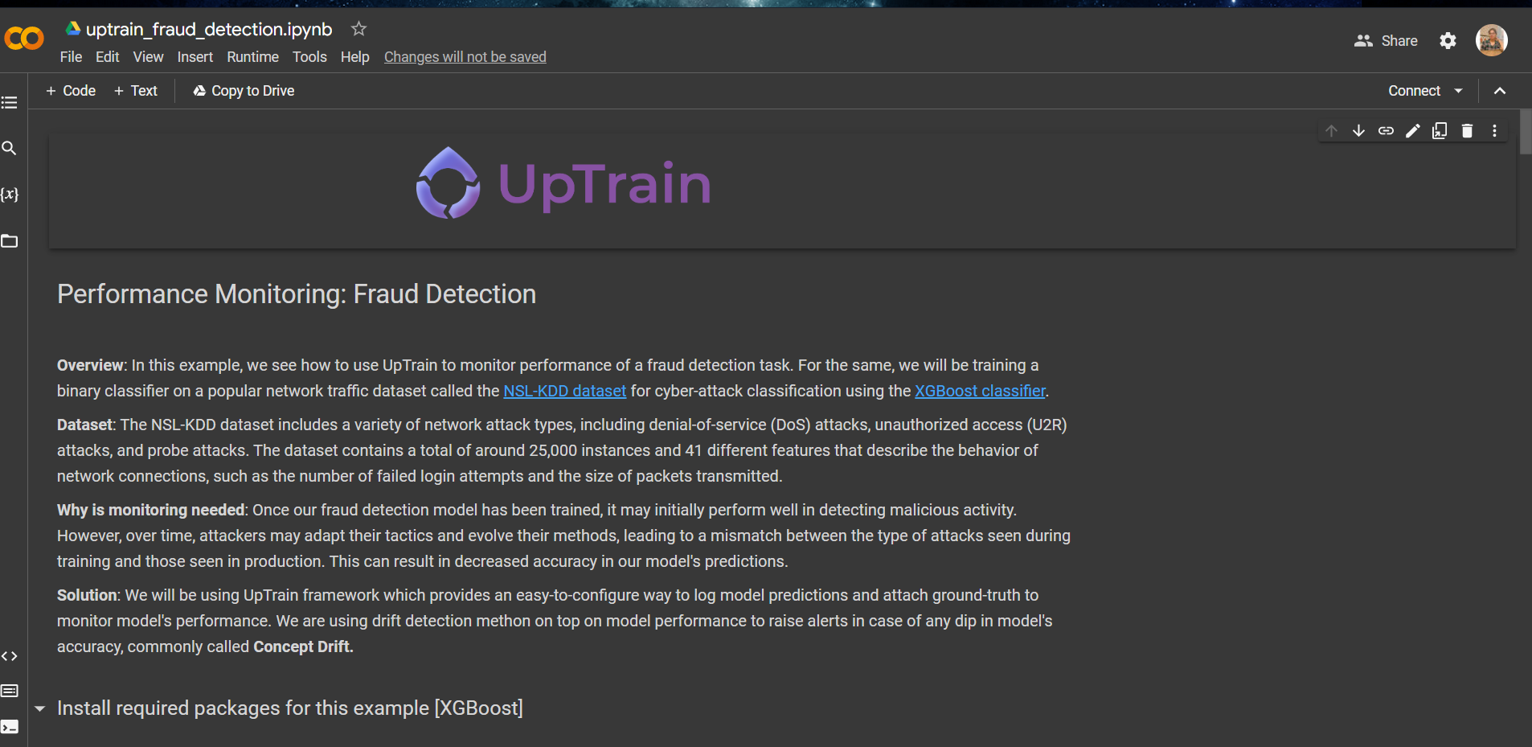**Try out the collab get started example in our repo**
2. **If you like the repo, star it *OR* if you don't like the repo, fill out the feedback form**

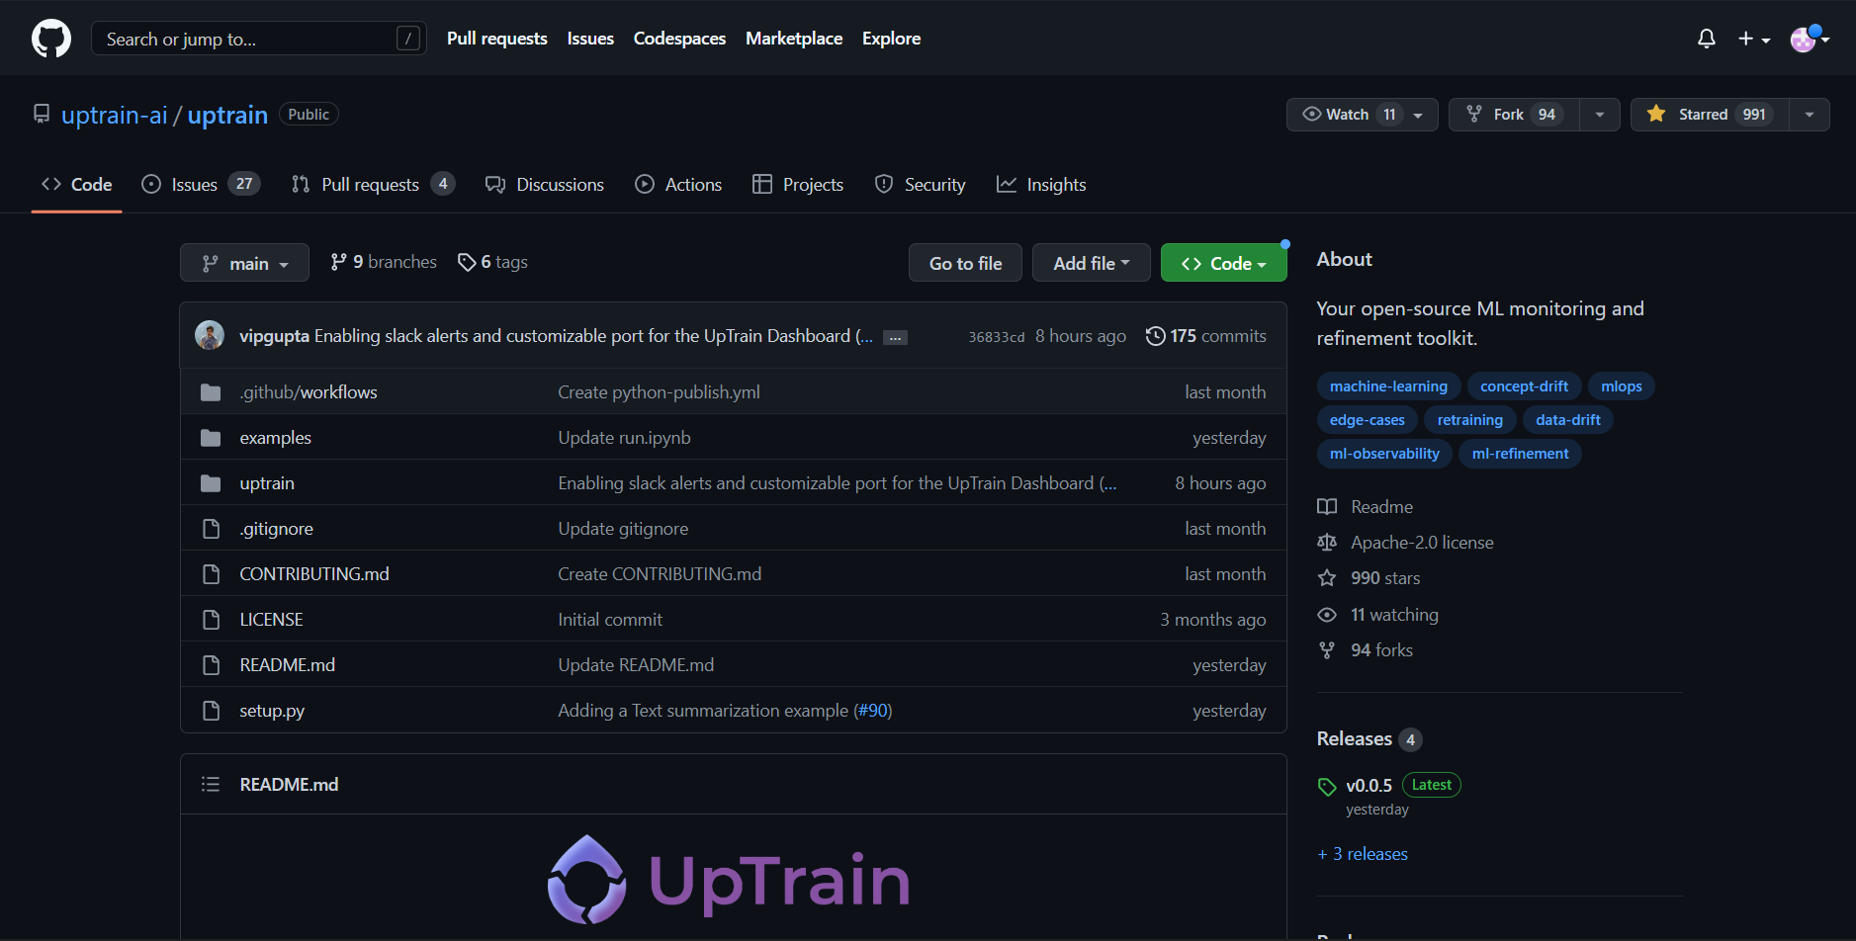

1. **Explain your understanding of getting started (orientation classification example) in 2-3 lines**

In this task, we have monitored performance of a **fraud detection task**. It is done by training a binary classifier on a popular network traffic dataset called the **NSL-KDD dataset** for **cyber-attack classification** using the **XGBoost classifier**.

1. **Suggest a new use case that could be added to the repo**

I suggest a case that is this can be used in detecting malicious activities performed by students while writing any online exam. We can send them an alert warning message when we detect any of the electronic device found or if there is change in tab while writing exam.

1. **Explain your understanding of the technical architecture**

In this task:

1. Initially, we have **installed required packages** (XGBoost)

2. Later, we **imported required packages** like uptrain, time , numpy, pandas etc.

3. Next, we **downloaded the dataset**, studied and **preprocessed** it.

4. Next we’ve divided our given dataset into 2 sets: **training and test data sets** and we’ve trained the model.

5. We’ve used **XGBoost Classifier**, which stands for Extreme Gradient Boosting, is a scalable, distributed gradient-boosted decision tree (GBDT) machine learning library. It provides parallel tree boosting and is the leading machine learning library for regression, classification, and ranking problems

6. **Monitoring model performance** using UpTrain

7**. Define a Custom Monitor** in UpTrain for better monitoring